**Econ and Math Grades on Cumulative GPA**

Data Overview:

The goal of this analysis is to understand the relationship between combinations of math and economics courses on the cumulative GPA of business students at different academic levels. The students course grade, number of courses taken in a subject, their academic standing, and when they took a course is also considered. The analysis included 5984 students from 2019 onward, and their Fall and Spring semester grade data. For this analysis classes were grouped into the following buckets based on their content: Pre-Calculus, Calculus, Post Calculus, Analytics, and Advanced Econ with Introduction to Finance 300, Principles-Microeconomics 101 and Principles-Macroeconomics 102 analyzed individually. The data includes an observation for every student at every academic level with their cumulative GPA average for each class grouping.

To account for students that did not take a course from each group we split the analysis into subsets and created categorical variables to in eliminate missing data before running our regression models.

Key Findings:

* There is less variance between class grades and cumulative GPA the further a student is in their academic career. With less classes to weight for at the beginning, these classes have a stronger influence on cumulative GPA. So, students’ cumulative GPAs stabilize the further along they are in their academic career.
* For our linear regression model, courses and groupings such as Microeconomics 101, Macroeconomics 102, Calculus and Advanced Econ grades have a stronger influence on predicted cumulative GPA.
  + When controlling for the other variables, a student who is in the A Range for these groups is predicted to have roughly a quarter GPA point higher in their GPA than a student who is in the B Range.
  + When controlling for the other variables, student who is in the D/F Range for these groups is predicted to have roughly 3/4ths a GPA point lower in their FPA than a student who is in the B Range.

By running a linear regression model that predicts Freshman's cumulative GPAs based on their average calculus grade, Principles-Microeconomics 101 grade, and whether they have taken Pre-Calculus or not; there are statistically significant positive correlations between Microeconomics, Calculus grade and the number of Calculus courses taken on cumulative GPA.

When expanding this model to all grade levels and adding whether students have taken courses in all the other class groupings as predictors, there continues to be statistically significant positive correlations between Micro and Macroeconomics and Calculus grades each with GPA. Overall, as shown by the plot below, the strongest positive correlation is between students’ calculus grades and their cumulative GPA.

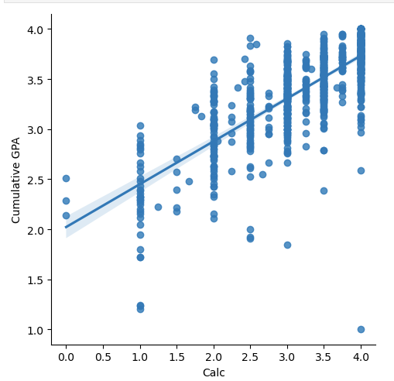

The correlations between cumulative GPA and how many courses a student has taken per group for all observations are shown in the table below. We were surprised by the negative correlation there seems to be between the amount of Calculus courses taken and their cumulative GPA.

|  |  |  |  |  |  |  |
| --- | --- | --- | --- | --- | --- | --- |
|  | Calc Count | Pre-Calc Count | Post Calc Count | Analytics Count | Advanced Econ Count | Academics Codes |
| Cumulative GPA | -0.123 | -0.288 | 0.0617 | 0.116 | 0.0894 | 0.170 |

To preserve all observations, we put each class groupings’ GPAs into categories. A linear regression model was made using these categorical variables and includes all grade levels and students. The model explained around 65% of the variance in cumulative GPA. Our baseline condition/ treatment group was set to a freshman with an average grade category of ‘B Range’. The model resulted in all class groupings, except Introduction to Finance 300, as statistically significant in explaining Cumulative GPA.

The plots per class group below show the density of cumulative GPA based on the grade they received in that course. For all class groups we can see that the A grade range (the lightest color) suggests a higher cumulative GPA. There is most fluctuation in the grade distributions for Pre-Calc and Calculus.

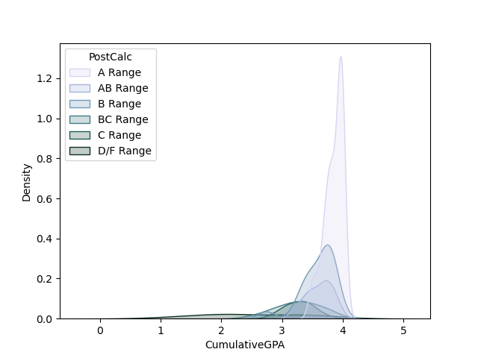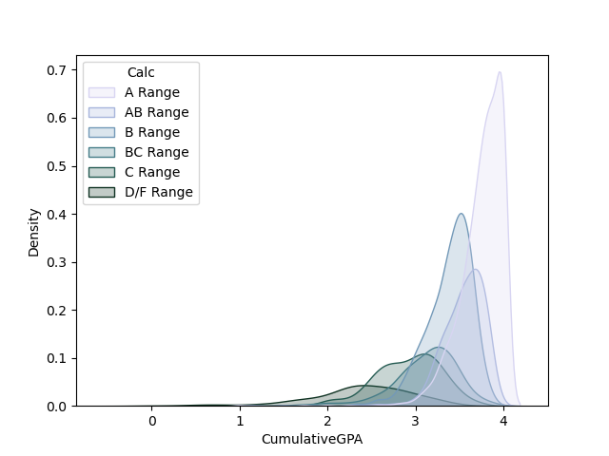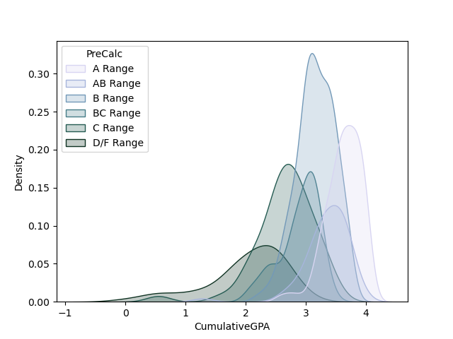

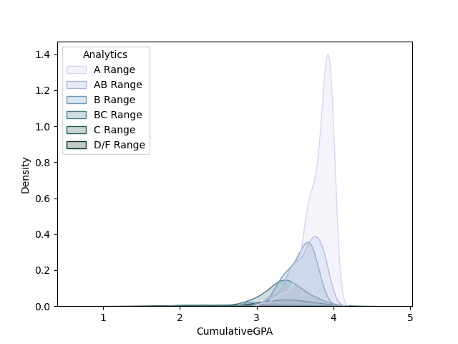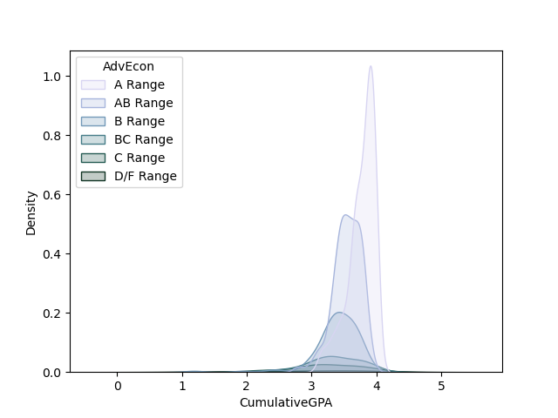

The following plots are broken up by class groupings and show the GPA students have in that group compared to their cumulative GPA. For all grade levels class grade correlates to a higher cumulative GPA, especially for freshman where it tends to be steeper because that is when cumulative GPA tends to fluctuate the most as previously mentioned. These plots also show which class groupings are generally more popular amongst academic levels.

